**CCL POETRY**

**9/24**

From Jenna Lé- *Manatee Lagoon* Acre Books ©2022

**Picky Picky**

I don’t want the whole sandwich,

just the cucumbers and mayo.

I don’t want an actual wedding,

just the license and the man.

I don’t want to have sex,

just the part that feels transcendent.

I don’t want to read your novel,

just the parts that are about me.

I don’t want to watch It’s a Wonderful Life,

just the ending, over and over.

I don’t want to listen to the Killers station on Pandora,

just the Killers, and just the songs I like.

I don’t want to learn guitar,

just enough to make you lick your lips.

I don’t want to master Latin,

just enough to dig Propertius.

I don’t want an Instant Pot,

just the meals that someone’s made in one.

I don’t want Daylight Savings Time,

just the hour we gain for free.

I don’t want all-wheel drive,

just the guarantee of safety.

I don’t want Sriracha hot sauce,

just for the Sriracha inventor to prosper.

I don’t want an Instant Pot,

just for the Instant Pot inventor to prosper.

I don’t want to write a poem,

just the words between the rhyme words.

I don’t want to write a poem,

just the rhyme words, nothing else.

**Please Don’t Tell Me How the Story Ends**

A Vermont man. Rural. Lacerated

his knee with a chainsaw

doing tree work one summer.

The wound festered, not angrily

but with a slow simmering

puzzlement. This lasted years.

One day he fingered it, felt

something hard inside, pulled

out a shiny piece of glass.

Another time, he pulled a blade

of grass out of it, then

a whole maple leaf, so perfect

it filled Canadian flag makers with envy.

Started feeling mighty proud of himself,

like King Arthur when he made that stone

belch up a sword. Began pulling

bigger and bigger things

out of his knee: a dime,

a dollar bill, a bandanna,

a quail’s egg. And the quail hatched, too.

Got to calling himself The Wizard,

made the circuit of local festivals,

state fairs. You’d think this story ends

some place bad—a psych ward,

O.R., or early grave—a wimpled lady

shoveling dirt on a corpse

that died of three parts delusion,

one part gangrene. But I think

the times have just gotten to you,

the pessimists opining on TV

have dragged you down to their level.

The Vermonter, he’s still

making the rounds, still finding

7-11 receipts, perfectly folded

road maps, and poetry broadsheets

tied with slim blue ribbons

in his knee. Sometimes butterflies

come foaming out, five or six at once,

beating lavender wings.

From Peter Vertacnik *The Nature of Things*  Criterion Books ©2024

**Lullaby For an Adult**

*–after Patric Dickinson*

All the doors are locked.   
The dog’s been walked.

Each tap, each burner off.   
No dome-light glows in the garage.

Through that cracked blind   
the streetlamp doubles

as your moon. You sleep alone   
but this bed’s warm.

Your dreams won’t paralyze   
or force contortions. Your face,

though pocked and stubbled,   
softens. The ticking clock

has gone; your pulse  
marks time, throbbing

through the splinter  
burrowed in your palm.

No termite, no errant spark   
will test these walls tonight.

From Mike Lala:The Unreal City Tupelo Press © 2023

 after Aszure Barton’s Lift at Alvin Ailey

I think it was something to do with labor—

the man, his body before me all muscle, skin like a contract holding him there,

lines pulled tight

and his joints at odd angles, body

capable, legs not unlike those folding to fit in their seats,

but visible

after the curtain has parted: cable, winch that pulls it through the pulleys,

then

his knees, his body at work,

part

of a sum

(a company): men, together—their bodies

in labor together,

for whom the audience puts their hands together

because that labor a work.

And then a part

of the women dancing

is shining thighs, their labor

evident in shining, the hands together again because

their movement a contract,

a kind of credit

that cannot be taken away, but only ignored,

and when they join the men, light on one man, the body of labor made center,

his sweat

in the stage lights,

glimmering

byproduct of the work he is paid to perfect and perform not for himself

but for me—I watch with my friend

whose compounding interest

and asset accrual allow us to be here—

the ushers, house lights, renovated ceilings, heat lamps in fog along 55th Street in the rain,

the hundreds of animals joining in dozens of fur coats damp with it,

almost like money (the fruit . . .

You grow.

You eat.

The thing with which you pay your debts or save . . .

of her labor added to theirs, the whole audience), sum

and accrual

flexing not unlike

the muscles their nerves arrange toward a work

exceeding the sum of their bodies in front of my skin,

a currency,

breathing a story—the labor of bodies other than mine—when a woman puts her face

in the pit of a man’s chest,

when his spine curves back to receive her,

is it labor,

or pleasure, or both—the sweat on his back—I feel—his breath

a product like smoke, a kind of evidence, proof

of a kind

of labor

not unlike love

and my purchase of it,

a clenching of muscle not unlike the lock of the winch releasing,

and she, midair,

allowing a break in the contract, a hole in the terms, a kind of evidence

of faith,

as if a bend at her waist, suspended,

into my ear, trust

extended

and my receipt.

Wrong with neglect.

The proof leaning forward. I do: I

can almost see—

----

My picture from July 2023

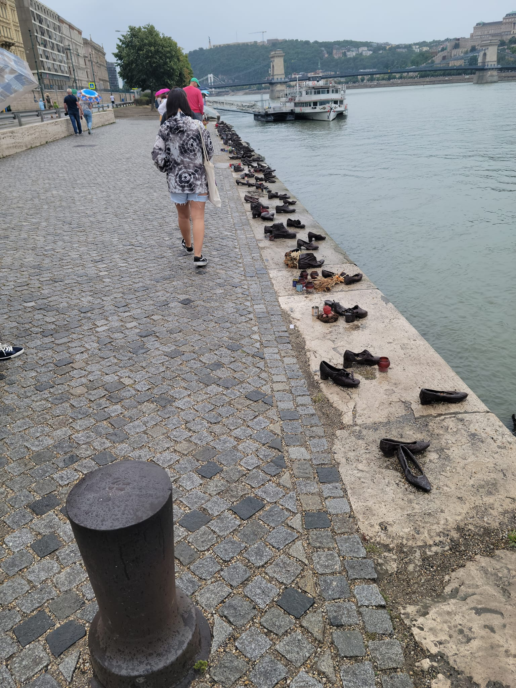

----

Susanna Rich

For Holocaust Remembrance Day, my poem from Ekphrasis:

Along the Danube Promenade

Wingtips, pumps, toe shoes,

strap sandals, boots—

sixty pairs of cast iron shoes screwed

into the concrete embankment—

shadows reaching into each other—

like the rope tying together the Jews in ’45.

The lucky ones were shot, fell into the river,

dragging children, fathers, friends down.

Shoes were valuable then, rammed

into Arrow Cross sacks, like potatoes.

But here they are, pointing to the water—

a pair angled, as if turning to ask something;

Another toeing the edge, like a diving board.

One missing hard laces. Unveiled in April.

Crow-barred in June—some gone

or tipped on their sides, mangled,

cigarette butts ground in—

black pegs, like worn teeth in the sun.

Yet the shoes sprouted

pink carnations and baby’s breath,

purple daisy flip-flops,

tiny prayer scrolls, rocks and pebbles

everywhere—snuck below stiff tongues,

sheltering under insteps, halo-ing edges.

I slip two volcanic stones, warm

from my pockets, into a pair of high heels

to say for them I am here.