12 Most Effective Chair Exercises for Seniors
1. Clenched fists and wrist circles
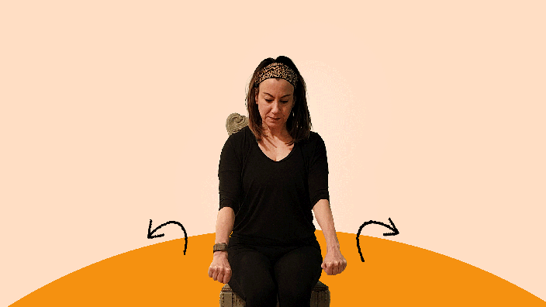
Warm up with low-intensity moves like wrist circles to promote circulation and prepare your muscles for exercise.
- Step 1: Sit up with your back straight and your feet on the floor.
- Step 2: Extend your arms straight out with your palms facing down.
- Step 3: Clench your fists, opening and closing them three times.
- Step 4: Roll your clenched fists in circles 10 times in each direction.

2. Ankle ABCs
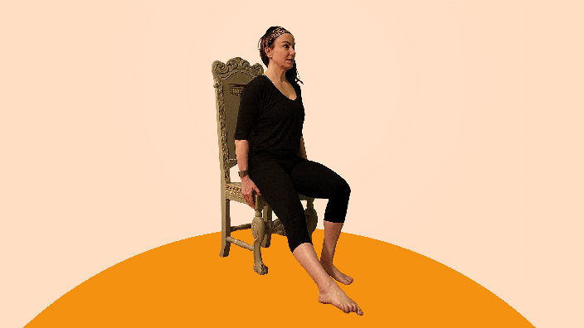
This move can boost ankle mobility, which helps keep you steady on your feet as you walk. It doubles as a stretching and strengthening exercise.
- Step 1: Sit tall with your feet on the floor and your palms resting on your thighs.
- Step 2: Lift one leg straight out in front of you.
- Step 3: Imagine your big toe is a pen. Use your toe to write the alphabet, making the letters as big as you can. Move your foot rather than your whole leg.
- Step 4: Repeat steps 2 to 3 with your other leg.
For an added challenge, you can try writing your name in cursive or spelling words backward.

3. Seated marches
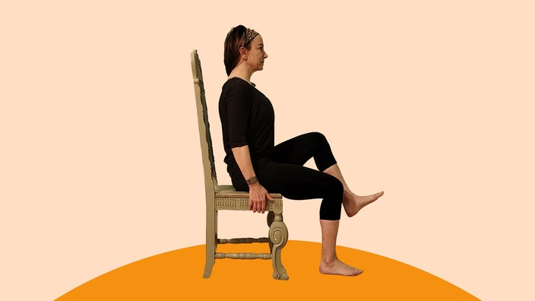
Get your heart pumping with seated marches. This exercise can boost flexibility and mobility in your hips and thighs.
- Step 1: Sit toward the front of your chair. Keep your back straight, your feet hip-width apart, and your arms at your sides.
- Step 2: Squeeze your abdominal muscles to engage your core.
- Step 3: Lift your right leg as high as you can while keeping your knee bent.
- Step 4: Lower your right foot to the floor slowly.
- Step 5: Repeat the move with your left leg to complete one rep.
- Step 6: Do two to three sets of 10 to 12 reps.

4. Seated jumping jacks
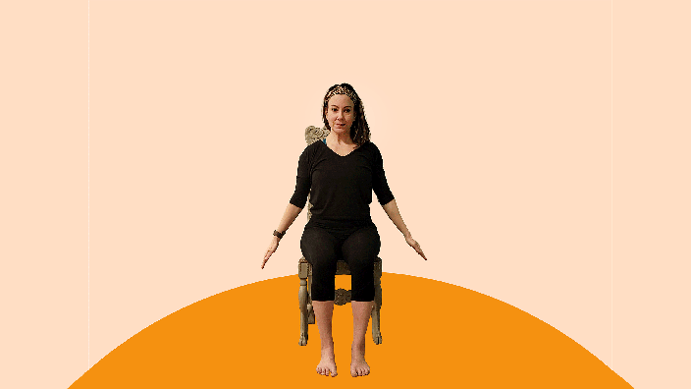
Transition to a full-body aerobic move with seated jumping jacks. The classic exercise supports bone and heart health and may help mobility and coordination.
- Step 1: Sit toward the front of your chair. Keep your back straight, with your arms at your sides and your feet together.
- Step 2: Draw your belly button toward your spine to engage your core.
- Step 3: Swing your arms overhead as you step your legs out about shoulder-width apart.
- Step 4: Return to the starting position by stepping your feet together and bringing your arms to your sides.
- Step 5: Do 10 to 12 reps as quickly as you can.
- Step 6: Complete two to three sets.

5. Sit-to-stands
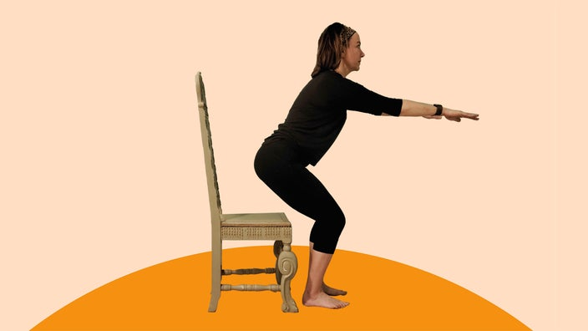
The sit-to-stand exercise works your legs, hips, abdominals, and other core muscles. It can strengthen your muscles and enhance your balance. This functional movement is critical for activities of daily living (ADLs), like getting in or out of a car.
- Step 1: Sit toward the front of your chair with your hands resting on either side of your thighs. Keep your spine straight and your feet hip-width apart.
- Step 2: Draw your belly button toward your spine to engage your core.
- Step 3: Lean forward from your hips, shifting your weight through your feet.
- Step 4: Stand up slowly, pausing for a breath while standing upright.
- Step 5: Shift your hips back, and bend your knees to sit back down.
- Step 6: Complete 10 to 15 reps.

6. Seated biceps curl
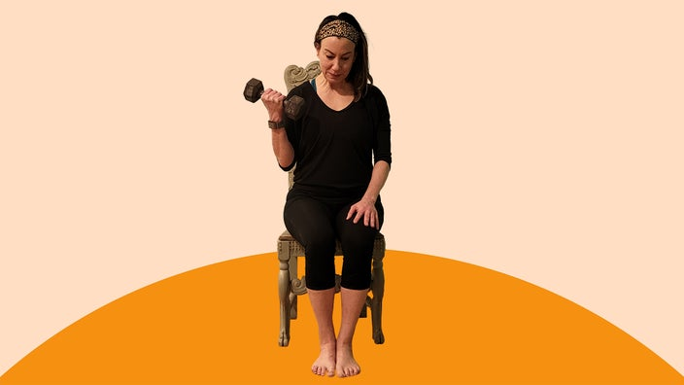
Seated biceps curls strengthen your upper arm, making it easier to pick up objects like your groceries. Typically, you use dumbbells for this exercise. Choose the amount of weight you lift based on your current health and fitness. For example, beginners might start with 1 lb to 5 lb dumbbells or household items like soup cans.
- Step 1: Sit with your shoulders down and your back straight. Keep your feet flat on the floor, shoulder-width apart.
- Step 2: Hold one dumbbell in each hand, with your arms straight and palms facing forward.
- Step 3: Exhale as you bend your elbows and slowly lift the dumbbells toward your shoulders. Pause for a moment, keeping your elbows tucked at your sides.
- Step 4: Inhale as you lower the weights, making sure the movement is slow and controlled.
- Step 5: Repeat 8 to 12 reps.
- Step 6: Pause for a few minutes and do one more set of 8 to 12 reps.

7. Standing leg curls
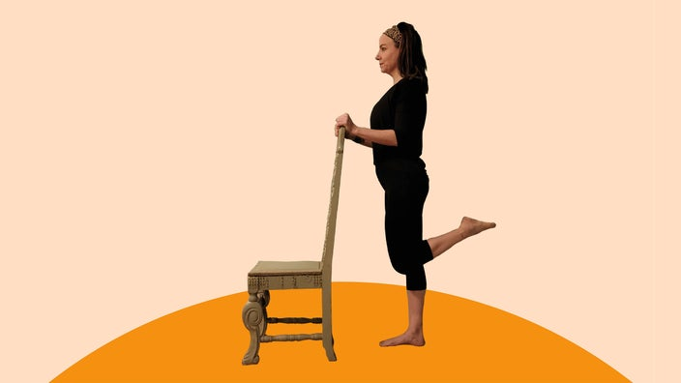
This leg strengthener primarily targets your hamstrings and calves. Strong hamstrings are critical for movements like walking up and down stairs. They may also improve sports performance and prevent injuries.
- Step 1: Stand tall behind a sturdy chair, holding the back of the chair for balance.
- Step 2: Engage your core, and shift your weight to your left leg.
- Step 3: Bend your right knee, bringing your heel as close to your butt as you can. Keep your hips still, and make sure your standing leg is slightly bent.
- Step 4: Hold the curl briefly, then lower your leg to the starting position.
- Step 5: Do 12 to 15 reps.
- Step 6: Repeat with your left leg.

8. Chest stretch
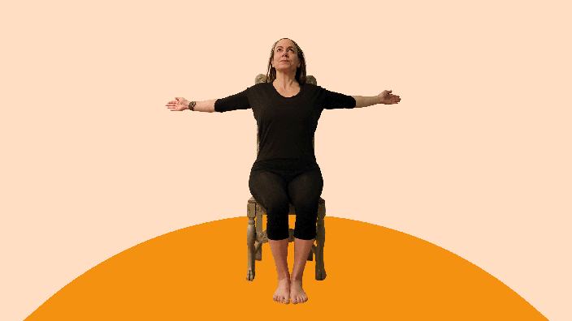
You can begin your cooldown sequence with this seated chest stretch, which may help your posture.
- Step 1: Stand or sit tall with your arms at your sides and your feet shoulder-width apart.
- Step 2: Extend your arms out to your sides with your palms facing forward.
- Step 3: Move your arms back slowly, squeezing your shoulder blades together.
- Step 4: Hold the stretch for 10 to 30 seconds before returning to the starting position.
- Step 5: Repeat three to five times.

9. Seated forward bend
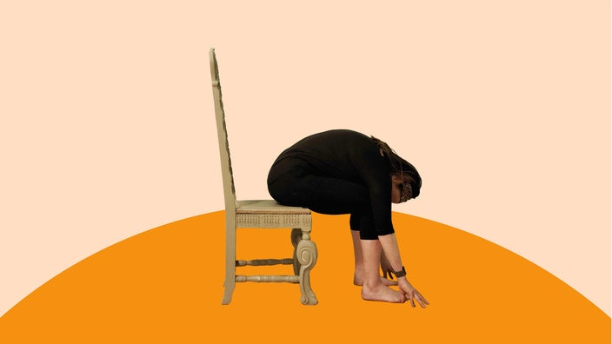
The seated forward bend lengthens your back muscles to increase flexibility.
- Step 1: Sit tall toward the edge of your chair with your feet shoulder-width apart.
- Step 2: Keep your back straight, and slowly bend forward from your hips.
- Step 3: Slide your hands down your calves as you continue bending forward, moving your chin toward your lap.
- Step 4: Hold the stretch for 10 to 30 seconds.
- Step 5: Straighten up slowly to return to the starting position.
- Step 6: Repeat three to five times.

10. Seated calf raises
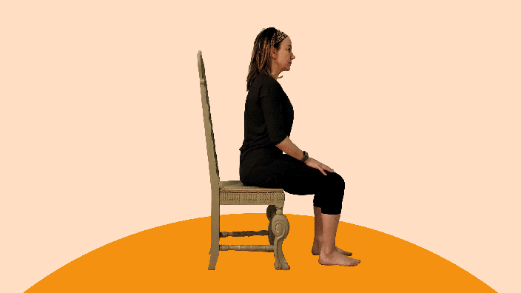
This move strengthens the muscles on the back of your lower leg. It also builds strength and mobility in the ankles. This can help you prevent falls and reduce your risk of ankle sprains and other injuries.
- Step 1: Sit down in a sturdy chair with your knees at 90 degrees and your feet flat on the floor.
- Step 2: Press into the balls of your feet and lift your heels up as far as you can. As you do this, contract your calf muscles.
- Step 3: Hold the contraction for 1 second at the top of the movement, then slowly lower your heels to the floor.
- Step 4: Do 12 to 15 reps.

11. Seated torso twists
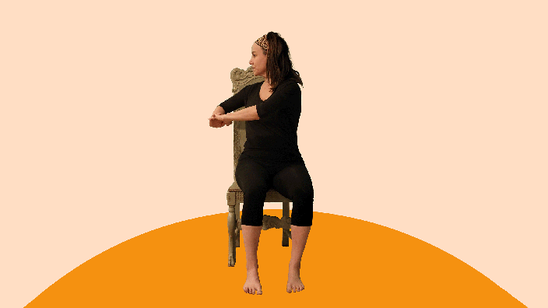
Developing strength in your core — the muscles in your abdomen and lower back — can help prevent injuries in your lower body, build stability and balance, and help you perform everyday activities with more ease. This move strengthens your core and stretches the muscles around your midsection.
- Step 1: Sit tall in a chair with your spine erect.
- Step 2: Lift your arms with the elbows bent, and clasp your hands in front of you.
- Step 3: Contract your core muscles, and slowly rotate your torso, shoulders, and head to the right as far as you comfortably can.
- Step 4: Hold here for a moment, then return to center.
- Step 5: Repeat in the other direction.
- Step 6: Do 10 reps on both sides.

12. Chair planks
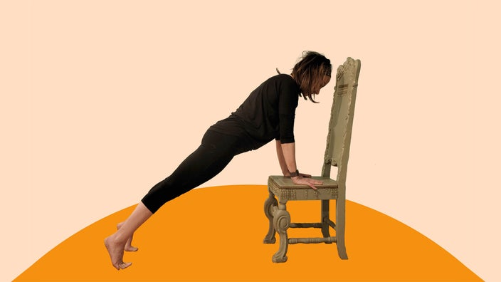
Planks are another exercise that helps build core strength. This move is normally done on the floor, but using a chair makes it more accessible if it’s hard for you to get down on the floor and stand back up.
- Step 1: Position a chair in front of you with the seat facing toward you.
- Step 2: Bend down and place your palms on the seat with your hands close to shoulder-width apart. Keep your shoulders aligned over your wrists.
- Step 3: Walk your feet out until your body forms one straight line from your head to your heels. Stand on the balls of your feet, and contract the muscles in your lower body, core, and upper body.
- Step 4: Hold here for 10 to 30 seconds, keeping your core muscles contracted. Don’t let your hips pike up or sag down.
- Step 5: Walk your feet back in and stand up.
- Step 6: Rest for 30 seconds and repeat two more times.

