

Center for Lifelong Learning

Liaison and Course Facilitator Handbook

**Table of Contents**

1.0 Welcome and Curriculum Chair information Page 3

* 1. Course planning Page 4
  2. Before the course begins Page 5
  3. Course and Classroom Preparation Page 6
  4. Facilitating the course Page 7-8
  5. Last day of course Page 9
  6. Attachments

A. Course Proposal form Page 10

B. Instructor Guidelines Page 11

C. Zoom Information Page 12-13

D. Example Script Page 14

E. Attendee Feedback form Page 15

F. Feedback Summary form Page 16

1.0 Welcome

Welcome to the Center for Lifelong Learning (CLL) Curriculum Committee. We are excited that you have joined us and look forward to getting you started.

When you join the Curriculum Committee you can participate as a facilitator or as a liaison. What is the difference in roles you may wonder? A **facilitator** is a volunteer who dedicates their time assisting with the actual course execution and feedback from attendees.

The **liaison** role is more involved and entails assisting with course planning, instructor selection, course and classroom preparation and finally facilitating the course. We will describe the responsibilities in the following pages where sections 1.1 through 1.6 pertain to the **liaison** and sections 1.4 through 1.6 pertain to the **facilitator**.

When you first join the Curriculum Committee, you may choose to start your adventure by supporting just the classroom activities as a facilitator. This role is equally as vital as the liaison role which pursues new courses for the curriculum. You may find one suits you better than the other. We welcome your feedback and are always looking for ways to continue improving and growing the program.

The Curriculum Committee meets once a month from 1-2pm and the liaisons and facilitators attend this meeting. During this meeting, new course ideas or updates on in-process courses are discussed. The Committee members should notify the Center for Lifelong Learning (CLL) Curriculum Chair if they cannot attend a scheduled curriculum meeting.

**Curriculum Chair:** Dan Gluvna **Phone**: 734-717-7712 **Email:** [dgluvna01@gmail.com](mailto:dgluvna01@gmail.com)

**Curriculum Coordinator:** Taryn Wallace **Phone**: 803 641-3741 **Email**: [Taryn.Wallace@usca.edu](mailto:Taryn.Wallace@usca.edu)

**Assistant Director:** Kari Warren **Phone**: 803-641-3681 **Email**: [kari.williamson@usca.edu](mailto:kari.williamson@usca.edu)

**Administrative Assistant:** Ruth Polland **Phone**: 803-641-3719 **Email**: [ruth.poland@usca.edu](mailto:ruth.poland@usca.edu)

**Volunteer Committee Chair:** Lynn Gluvna **Phone**: 734-657-6789 **Email**: [lgluvna@gmail.com](mailto:lgluvna@gmail.com)

**1.1 Course Planning**

1. As soon as a semester is completed, the search begins for instructors and courses for the next semester. As you, the liaison, begin your search, send each of your prospective instructors a personal email asking them to consider teaching a course for the next semester.
   1. Give them the start date and end date for the upcoming semester for planning purposes.
   2. Attach a C*ourse Proposal form\*\** with the *Instructor Guidelines\*\** (see Attachments A and B) to your request (fill in the liaison information on it before you attach it).
   3. Give the instructors the date by which you will need the information.
   4. If the instructor needs more information or examples of other courses, direct them to the Center website. ([www.aikenlearning.org](http://www.aikenlearning.org) ).
2. Send periodic reminders of the proposal due-date (every month or so) until you receive either the completed form or a decline to teach.
   1. Most proposals concern easy to recognize subjects. If there is any doubt about the appropriateness of the proposal description, bring it up at the Curriculum Committee meeting or discuss it with the Curriculum Chair.
   2. If you know the prospective instructor and feel he/she is not a good fit for our program, let the Curriculum Committee know.
3. Proposals for new courses should be submitted on the standard *Course Proposal form* and an electronic copy submitted to the Curriculum Chair. This form is designed to capture information needed to compile the course catalog.
4. If the instructor has not previously instructed for CLL before, they will be supplied with instructions on how to register on the USC Suppliers website (to ensure payment).
   1. If the instructor’s course proposal form indicates that it is a public service course, no paperwork will be sent.
   2. Instructors are paid $75 per course session, regardless of the length of the course (max. 4 sessions) or the number of instructors. If the course has an admission fee, instructors will be paid $75 or the admission fee, but not both.

5. Scheduling of courses begins on the date that the *Course Proposal form* is due. Attempts will be made to accommodate the instructor’s request for dates. If there is a conflict with obtaining those dates, the Curriculum Chair or liaison will contact the instructor to find alternate dates.

**1.2 Before The Course Begins**

1. The liaison will ensure that the instructor has received a copy of the Lifelong Learning *Instructor Guide* which can be found on the CLL website (<https://aikenlearning.org/forms/> ).
   1. The *Instructor Guide* should have been sent with the *Course Proposal form*.
2. After the course has been scheduled, the Curriculum Chair will send out the course information to the liaisons, showing the course information as it will appear in the catalog. The due date for the instructor’s approval will also be given.
   1. The liaison will send a copy of the instructor’s SCHEDULED course information to them immediately, asking for their approval or editing of the information.
   2. Make them aware of the deadline date. You may need to remind the instructors of the date if you do not hear from them in a few days.
   3. If you do not hear from them by that date, the information will be deemed correct and will be used for the catalog input.
3. The liaison may need to obtain a temporary parking pass for the instructor if they do not have one. Check with the Administrative Assistant in Room 103 for the current procedure for accomplishing this.
4. Keep the instructor informed about any time change or classroom change.
5. If an instructor has course material (handouts or PDF of Power Point presentation) that would enhance the attendee’s experience of the course, that material may be distributed in advance of the course by following the below procedure:
   1. The Administrative Office of the Business and Education Bldg (room 103) needs to be notified at least 1 week in advance of the course for anything that should be printed or distributed for the class.
   2. The liaison should obtain a digital copy of the material and send it via email to the Curriculum Coordinator.
   3. The Curriculum Coordinator will email the material to all who are registered for the course.

**1.3 Course and Classroom Preparation**

1. The liaison should send a copy of the course information to the instructor at least one week before the first course session as a reminder. (The liaison can obtain this information from the catalog at [www.aikenlearning.org](http://www.aikenlearning.org) ).
2. Remind the instructor that course material (PowerPoint presentation) should be on a flash drive.
3. Check with the instructor what equipment (i.e. display table, AV equipment) they need to conduct their course and inquire if they would like any AV training. Emphasize the training option if this is a Zoom class.
4. If either the liaison or the instructor needs an A/V training session before the course begins, the liaison will arrange this with the Continuing Education office (room 126).
   1. This is especially important if the class is a Zoom class. The liaison should feel comfortable with aspects of zoom and how to connect the computer to a Zoom meeting and display the instructor’s slides.
5. The liaisons can choose which courses they would like to facilitate from the ones they bring in.
   1. The courses they do not choose to facilitate go into the class pool. From here, those courses are assigned by the Curriculum Chair to facilitators.
   2. The Curriculum Chair or liaison should forward a copy of the Course Proposal Form to the facilitator to ensure they have course information as well as any special needs the instructor may have for the course.

**1.4 Facilitating the Course**

1. If the liaison will not be facilitating the course, they are to notify the instructor who their facilitator will be.
   1. The facilitator for the course will be notified by the Curriculum Chair and given the course information.
2. If the facilitator needs an A/V training session before the course begins, we will arrange this for them.
   1. This is especially important if the class is a Zoom class. The facilitator should feel comfortable with aspects of Zoom and how to connect the computer to a Zoom meeting and display the instructor’s slides.
3. Prior to the actual course, the facilitator/liaison will receive an email from the Curriculum Coordinator of External Programs that contains the *Attendance sheet*. Print this off and bring it with you to each session of the course so attendees can mark their attendance.
   1. On the initial day of the course, stop by the Continuing Education office, Rm 103, to see if there are any updates to the *Attendance sheet* (additional attendees).
      1. There might be a desk with a folder on it in the hallway outside office 103 that will contain Attendance sheets or Attendee Feedback forms.
4. The facilitator/liaison shall arrive 30 minutes before the scheduled start time of the course to
   1. Make sure the room is available/open; greet instructor; put out *Attendance sheet.*
   2. Ensure the room has any equipment the instructor requested and that the computer/overhead projector work.
   3. If a Zoom class, ensure you can log into Zoom and pull up the instructor’s slides. (For Zoom instructions, see Attachment C)
   4. If you encounter problems with the scheduled room (room locked, technical difficulties, etc), please go to room 103 and ask for assistance.
5. The facilitator/liaison will introduce the instructor and review general housekeeping for the course at the first session, following a script provided by the Curriculum Committee. **The first day script can be found in the attachments** (Example Script--Attachment D**)** (you don't have to read it verbatim, but please be sure to cover all the points listed).
6. The facilitator/liaison will make sure each course session begins and ends on time. Work with the instructor to maintain an optimal learning environment for attendees.
7. The facilitator/liaison will make sure the instructor is informed of any course/room changes. The Continuing Education office will notify the attendees.
8. After each course session, make sure to collect the *Attendance form* as you will use the same form for each session of that course. Drop off the *Attendance form* in the Continuing Education office, Room 103. There is a folder in the office or outside of room 103 for *Attendance forms*.
9. If you are facilitator/liaison for a course and it is multiple sessions and you are unable to attend one of them, you are responsible for
   1. Finding a replacement for the date(s) you cannot be present.
   2. Reminding the facilitator/liaison covering for you to retrieve the *Attendance form* from the folder in the Continuing Education office. Also remind them to replace the *Attendance form* back in the folder after the session.
10. Should the facilitator develop a relationship with the instructor, they can ask the liaison (who brought in the class) if they would allow them (the facilitator) to become the liaison for the class, as well as the facilitator.

**1.5 Last Day of Course**

1. On the last day of the course (if 1-day course, it will be on the day of that course), provide attendees with the *Attendee Feedback form\*\** (Attachment E) for completion. Blank copies of this form should be in the classroom.
   1. Encourage the attendees to complete the form because we would like their feedback on the course as well as additional course ideas and we are always looking for potential volunteers.
   2. The Continuing Education office (room 103) will have copies of the *Attendee Feedback form* that you can grab (on the table right as you enter into that office) if there are not any in the class room.
   3. Remind the attendees that The Center for Lifelong Learning is run by volunteers and we need their help. If they are interested in volunteering, they can put their information on the *Attendee Feedback form*, talk with the liaison after class, or contact our Volunteer Committee Chair ([vol@aikenlearning.org](mailto:vol@aikenlearning.org)).
2. Collect the *Attendee Feedback forms* and the *Attendance form*.
3. Ask the instructor if they would like to view the *Attendee Feedback forms* before they go. (**Do not** allow them to take the *Attendee Feedback forms*).
4. You will then review the *Attendee Feedback forms* yourself and complete a *Feedback Summary\*\** (Attachment F)..
   1. The original *Attendance form* is to be placed in a folder marked ‘Attendance’ in the Continuing Education office, Room 103.
   2. The *Attendee Feedback forms* and *Feedback Summary* will go to the Assistant Director.
   3. The Curriculum Chair should be sent an electronic or printed copy of the *Feedback Summary*.
5. If attendees ask for hard copies/slides from the course and the instructor approves
   1. Have the instructor send the facilitator/liaison and/or Curriculum Coordinator a copy of the material (links and documents) they would like to share.
   2. The Curriculum Coordinator can send the material to the attendees unless it is too large to send through the university system. If material comes to the facilitator/liaison only, the facilitator/liaison will forward to the Curriculum Coordinator for distribution.
6. Finally, be sure to write a thank-you note to the instructor after the course is completed. You can obtain CLL notecards from the Continuing Education office and mail the notes yourself or drop off with the Administrative Assistant in the Continuing Education office, Room 103.

**If you cannot find blank copies of any of the forms, they can be found at <https://aikenlearning.org/> . Scroll to bottom of page and select ‘Resources’ then ‘Forms’. From the menu available, select desired form(s).

**Attachment A**

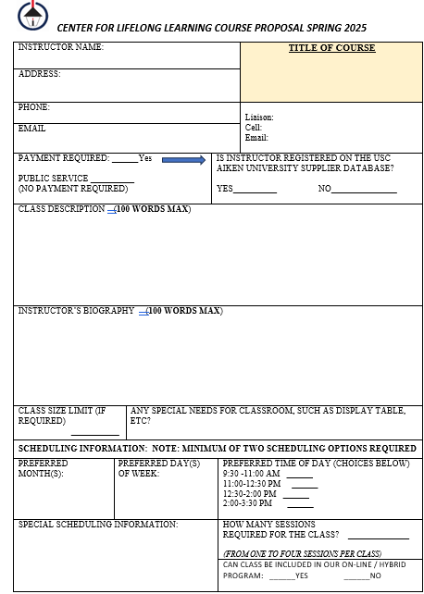

EXAMPLE

**Attachment B**

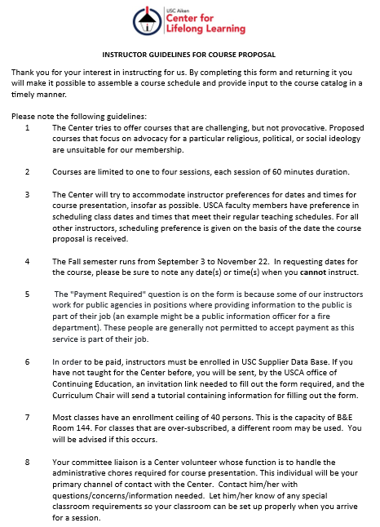

**Attachment C**

**ZOOM INSTRUCTIONS**

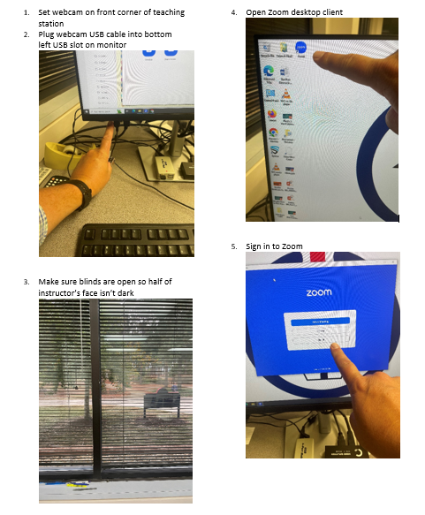

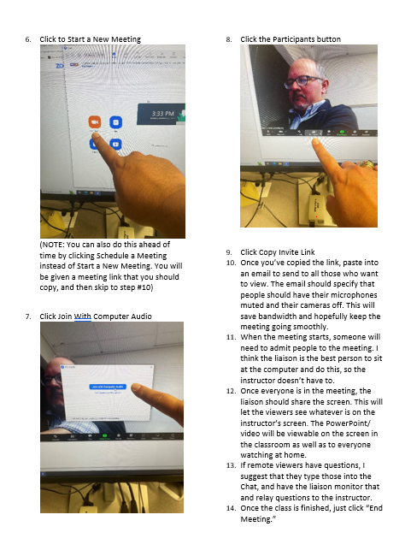

**Attachment D**

**EXAMPLE SCRIPT**

Hi, there!

Welcome to the Center for Lifelong Learning USC Aiken Class (course name).

My name is (your name) and I'm the facilitator with the General Interest Curriculum Committee.

I would like to cover a few things before we get started:

• Point out exits in case of an emergency.

• Point out locations of rest rooms.

• Please turn off your cell phones (or any similar items you have with you).

• Please sign in. The attendance sheet is on the table near the door. If you forgot, you can sign the attendance sheet on your way out.

• Check that you are parked between white lines. The yellow lines are for university faculty and staff only. If you have a handicap sticker, there are handicap parking places for students, as well.

• Now let me provide a little information on our instructor (Facilitator can obtain a short bio on the instructor from the course catalog).

**Attachment E**

**ATTENDEE FEEDBACK FORM**

|  |  |
| --- | --- |
| ***FEEDBACK*** | |
| **THIS CLASS** | NAME OF CLASS: |
| How would you rate this class: |
| COMMENTS ABOUT THIS CLASS (APPLAUSE AND/OR BOOS!): |
| **ABOUT CLL IN GENERAL** | COMMENTS / SUGGESTIONS / CLASSES YOU WOULD LIKE TO SEE OFFERED / INFORMATION / ETC.  EXAMPLE |
| IF THIS CLASS WASS OFFERED ON-LINE. WOULD YOU CONSIDER VIEWING A CLASS VIA THE ZOOM APP IF YOU WERE NOT ABLE TO ATTEND IN PERSON? **Yes** **No** |
| **VOLUNTEERING** | CLL’S STAFF ARE ALL VOLUNTEERS. THERE ARE MANY VOLUNTEER ROLES THAT NEED TO BE FILLED. **WE NEED YOU!** |
| IF YOU’D LIKE TO HAVE THE CHAIR OF THE VOLUNTEER COMMITTEE GET IN TOUCH WITH YOU, GIVE US YOUR CONTACT INFO BELOW:  NAME:  EMAIL:  TELEPHONE:  Or send an email to [vol@aikenlearning.org](mailto:vol@aikenlearning.org) . |

**Attachment F**

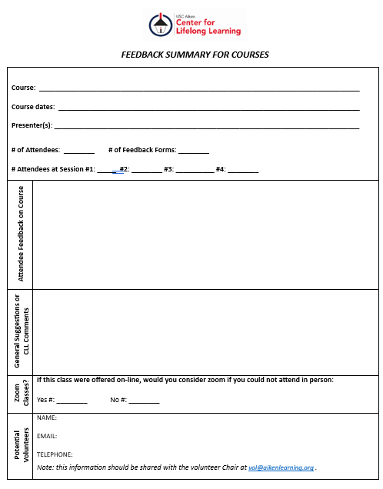

EXAMPLE